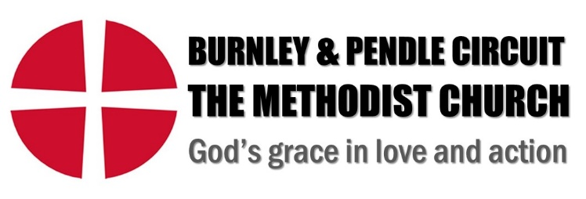

Job Description

Job Title: | Youth Pastor
Salary: | £27,865.25 | Hours per week: | 35
Location: | Across Circuit | Circuit: | Burnley & Pendle Methodist Circuit
Responsible to: | Line Manager | Relationships: | Circuit Leadership Team  Circuit Meeting  Ministers, lay employees and volunteers across the Circuit and its churches  Key stakeholders within the community (schools, voluntary and community organizations, families)

Job Purpose and Objectives
The postholder will develop and grow our youth ministry, enabling young people to be fully engaged in the life of the Circuit and its churches. The role will work to inspire our young people in their faith and help them to fulfil their potential.

Key Responsibilities

Develop and coordinate the youth strategy for the Circuit by:

Identifying existing groups and opportunities across our churches & local community to further extend and grow provision for young people;
- Further developing existing and ongoing work with Y6 pupils and above at the monthly Youth Gathering;
- Establishing connections among young people of secondary school age, developing links with local secondary schools, clubs, and social action projects;
- Providing pastoral support to young people and their families as appropriate;
- Planning and developing worship appropriate for this age group.
- Developing youth ministry and the introduction and development of faith to young people, nurturing them towards discipleship through the coordination and delivery of resources, events, worship;
- Establishing and fostering engagement with parents & carers;
- Establishing and developing a gathering place/s for a Circuit Youth group;
- Assisting churches to think strategically about engaging young people;
- Promoting safe, inclusive, and welcoming environments for all young people
- Adapting activities and projects to meet the needs of young people
- Advocating for young people to ensure the Circuit is a community in which their needs are considered and included;
- Participating in church life in the Circuit to build relationships with the community, volunteers, and families
- Engage with local, regional and national children and family networks.
- Recruit, support and identify training needs of team members, both paid and voluntary.
- Ensure compliance with safeguarding, health and safety, GDPR policies and other relevant statutory and legal requirements.
- Regularly plan, record, deliver and review activities and projects (at least weekly) and attend leadership meetings to present reports on youth ministry as required.
- Manage the youth ministry budget and resources in consultation with the Circuit Treasurer, and apply for funding as appropriate.

Terms and Conditions
- Normal working hours: 35 hours pw flexible to be agreed with the postholder.
- 25 days annual leave including statutory public holidays.
- Contribution to a personal pension.
- All reasonable expenses will be reimbursed.
- Appointment will be subject to a satisfactory enhanced Disclosure and Barring Service (DBS) disclosure.
- Appointment will be subject to the satisfactory completion of a six-month probationary period.
- Support will be provided to maintain and develop your faith and spiritual life including through the provision of a spiritual mentor and the opportunity to attend retreat days.
- The post will be accountable to line manager, Circuit Leadership Team and Circuit Meeting, and provide reports to Circuit Meeting as required.

