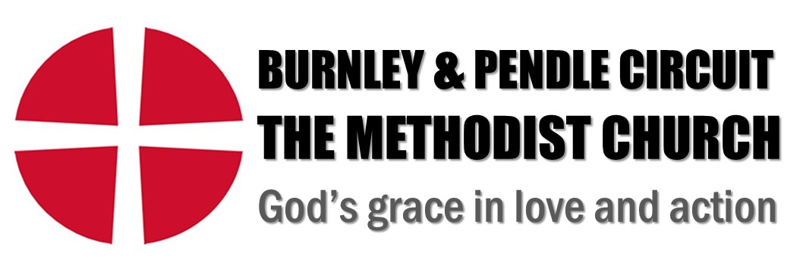
Person Specification
Youth Pastor
 | Essential | Desirable | Method of Assessment
Education & Training
Degree and/or recognised professional qualification in a relevant discipline (children/youth work, community work, general ministry, theology) |  |  | A/Q
Evidence of continuing professional development |  |  | A/Q
Proven Abilities
Experience of youth and/or community work and service outside of the church building |  |  | A/I
Experience of working and building positive relationships with children and young people to inspire them in faith and discipleship |  |  | A/I
Experience of setting up new projects, designing activities, and event planning and delivery for young people |  |  | A/I
Experience of delivering worship with and for young people aged 11yrs and above in a church and community setting |  |  | A/I
Able to organise and manage own workload and workload of others as appropriate |  |  | A/I
Be able to recognise and respond to emotional, mental health or other personal concerns and engage professionals if required in consultation with Line Manager |  |  | A/I
Able to communicate the Christian faith in engaging and relevant ways |  |  | A/I
Able to motivate self and others |  |  | A/I
Able to recognise and develop gifts/talents of others |  |  | A/I
Special Knowledge & Skills
Experience of leading and developing a wide team of volunteers |  |  | A/I
Experience working with children, young people and families from a wide range of backgrounds, including those with additional needs |  |  | A/I
Passionate about working with young people and sharing and exploring faith, presenting a strong Christian example |  |  | I
Experience in developing and nurturing young leaders |  |  | A/I
Skills in performing arts (e.g. music, drama) |  |  | A/I
A proficient communicator (written, verbal, listening) |  |  | A/I
Knowledge of the needs and issues affecting young people and families today |  |  | A/I
Knowledge of key compliance and legal requirements relating to this area of work (safeguarding, child protection, GDPR, health & safety) |  |  | A/I
Excellent social and interpersonal skills |  |  | A/I
A commitment to inclusion |  |  | A/I
ICT skills (including office packages as well as social media and online communication) |  |  | A/I
Any Other Requirements
Be an active member of the Christian community |  |  | A/I
Knowledge of the Methodist Church including ethos, structures and governance |  |  | A/I
Able to work evenings and weekends as necessary |  |  | A/I
Willingness to engage in appropriate continuous professional development |  |  | A/I
Ability to travel across the Circuit |  |  | A/I
A satisfactory enhanced disclosure with the relevant barred list checks from the Disclosure and Barring Service (DBS) |  |  | A

Method of Assessment
A – Application Form, I – Interview Q – proof of qualification (certificates or transcripts)
P – Presentation

